**Before using either R Shiny Application**

1. R and RStudio must be downloaded. Instructions for Windows or Mac can easily be found with a simple google search.
2. Once you have installed R and RStudio, you must install the following packages into RStudio:
   1. The packages are: shiny, shinyFiles, tidyverse, proxy, sportyR, plotly, ggrepel, shinyWidgets, lubridate, ggExtra, shinyjs, shinybrowser, shinycssloaders, ggforce
3. After you have done this, you are ready to run the applications on your desktop or laptop.

**How to use the Data App:**

1. To use the Data app to rotate and clean data: first you must open 3 files from the Data App folder: server.R, global.R and ui.R
   1. R Studio should look like this:
   2. Graphical user interface, text, application

      Description automatically generated
2. Once you have opened these 3 files click run app in the upper right hand corner:
   1. Graphical user interface, text, application

      Description automatically generated
3. Once you have done this your screen should now look like this:  
   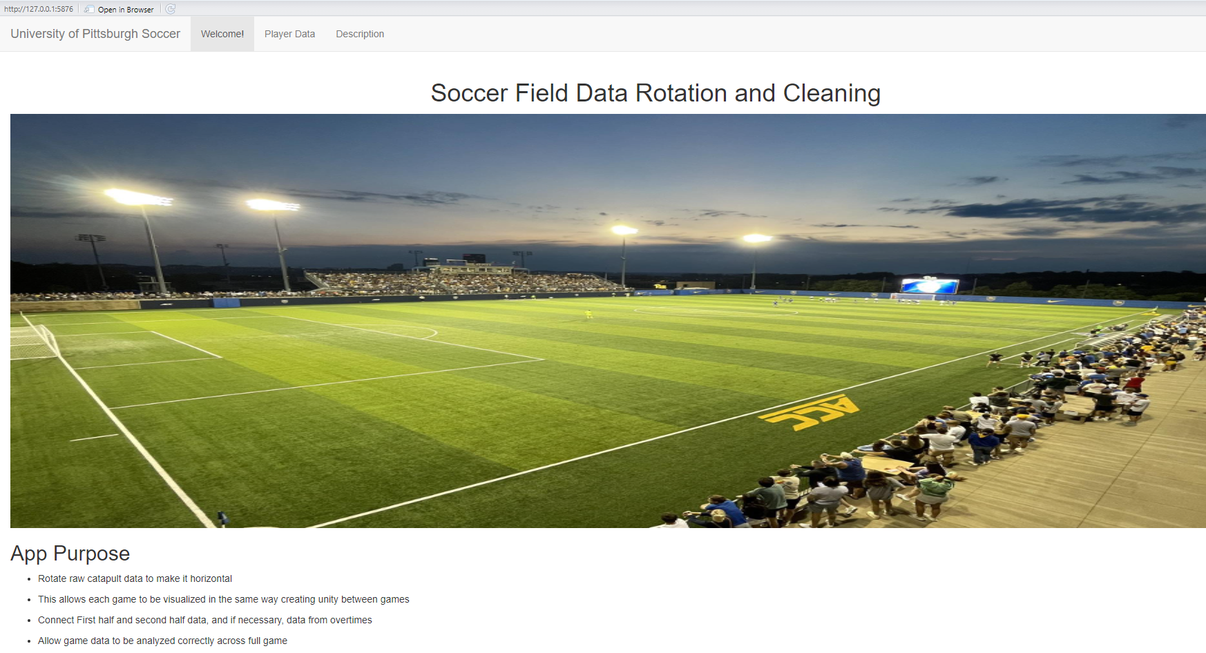
4. Now you can click the player data tab:
   1. Graphical user interface, application, Word

      Description automatically generated
5. Your screen should look like this:
   1. Table

      Description automatically generated
6. Now the first thing you should do is click browse and locate the the folder where you have all the game files for one game stored
   1. Table

      Description automatically generated
   2. Your screen should look something like this.
   3. You must select all files from the game to rotate and clean them for the optimal usage of the visualization application.
7. Once this pops up you are ready to input more data:
   1. Table

      Description automatically generated with medium confidence
8. Check the location drop down to see if the field is already stored. This will make it faster.
   1. Graphical user interface, application

      Description automatically generated
   2. If it is stored you should select the field
      1. Graphical user interface, application

         Description automatically generated
   3. If it is not stored, you will have to manually enter the corner point (the latitude and longitude coordinates) for each corner. Make sure to put each corners lat and long in boxes right after another.
      1. Table

         Description automatically generated with medium confidence
9. Now, enter the rest of the game information and click rotate data.
   1. Graphical user interface, application

      Description automatically generated
10. After you click rotate your screen should look like this:
    1. Table

       Description automatically generated
11. Now you should click download data, and navigate to the CleanedGames folder inside the Visualization app: Logo

    Description automatically generated with medium confidence
    1. Graphical user interface, text, application

       Description automatically generated
    2. And click save.
12. Now you are ready to use the visualization app.

**How to use the Visualization App:**

1. To use the Visualization app: first you must open 3 files from the Visualization App folder: server.R, global.R and ui.R
   1. R Studio should look like this:

2. Once you have opened these 3 files click run app in the upper right-hand corner:

* 1. Graphical user interface, text, application

     Description automatically generated

3. Your screen should look like this:

6. Choose your game:

7. Click choose game:

8. Once this pops up, you are ready to visualize the selected games data!

9. Whenever you would like to switch the game you are visualizing, you must navigate back to the game selection tab and choose the new game you would like to visualize.